ASSIGNMENT -3
N.VISHNU 20R15A0420
1)CODE FOR DHT11 – TEMPERATURE AND HUMIDITY SENSOR
#include "DHT.h"
#define DHTPIN 4
#define DHTTYPE DHT22
DHT dht(DHTPIN, DHTTYPE);

void setup() {
Serial.begin(9600);
Serial.println(F("DHTxx test!"));

dht.begin();
}

void loop() {
delay(2000);

float h = dht.readHumidity();
// Read temperature as Celsius (the default)
float t = dht.readTemperature();
// Read temperature as Fahrenheit (isFahrenheit = true)
float f = dht.readTemperature(true);

if (isnan(h) || isnan(t) || isnan(f)) {
Serial.println(F("Failed to read from DHT sensor!"));
return;
}

// Compute heat index in Fahrenheit (the default)
float hif = dht.computeHeatIndex(f, h);
// Compute heat index in Celsius (isFahreheit = false)
float hic = dht.computeHeatIndex(t, h, false);

Serial.print(F("Humidity: "));
Serial.print(h);
Serial.print(F("% Temperature: "));
Serial.print(t);
Serial.print(F("°C "));
Serial.print(f);
Serial.print(F("°F Heat index: "));
Serial.print(hic);
Serial.print(F("°C "));
Serial.print(hif);
Serial.println(F("°F"));
}

SERIAL MONITOR.
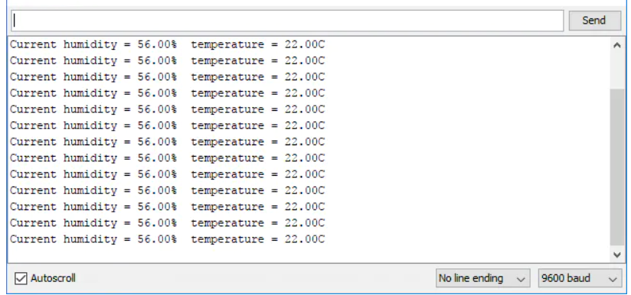

2) CODE:- LIGHT INTENSITY USING LDR

void setup() {
// put your setup code here, to run once:
Serial.begin(9600);
}

void loop() {
// put your main code here, to run repeatedly:
int a=analogRead(15);
Serial.println("ldr value is");
Serial.println(a);
delay(2000);
}

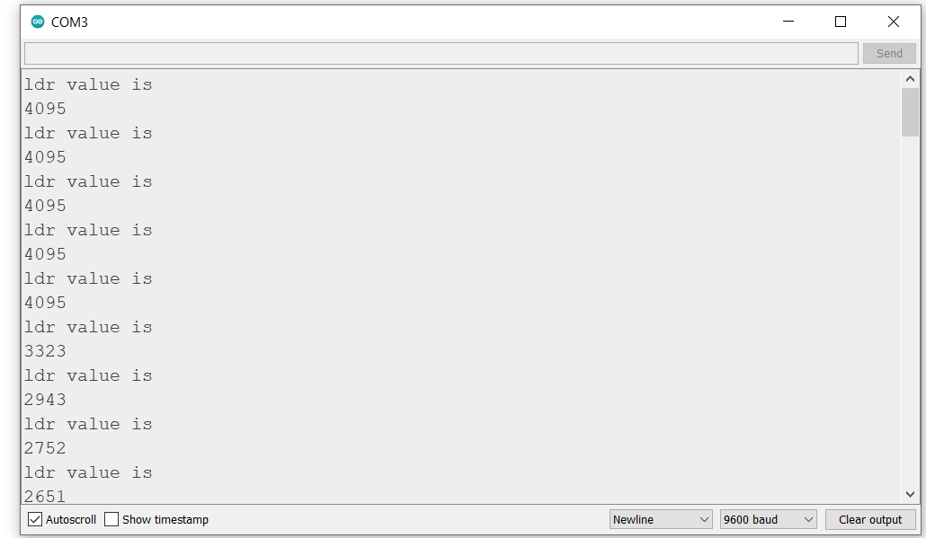

3) DISPLAY LDR VALUES, TEMPERATURE AND HUMIDITY ON OLED
#include <Wire.h>
#include <Adafruit_GFX.h>
#include <Adafruit_SSD1306.h>
#include "DHT.h"
#define SCREEN_WIDTH 128 // OLED display width, in pixels
#define SCREEN_HEIGHT 64 // OLED display height, in pixels
#define DHTPIN 4
#define DHTTYPE DHT11
// Declaration for an SSD1306 display connected to I2C (SDA, SCL pins)
Adafruit_SSD1306 display(SCREEN_WIDTH, SCREEN_HEIGHT, &Wire, -1);
DHT dht(DHTPIN, DHTTYPE);
void setup() {

Serial.begin(115200);
delay(2000);
Serial.println("oled test");
if(!display.begin(SSD1306_SWITCHCAPVCC, 0x3C)) {
Serial.println("SSD1306 allocation failed");
Serial.println(F("DHTxx test!"));

dht.begin();
for(;;);
}
delay(2000);
display.clearDisplay();
display.setTextSize(1);
display.setTextColor(WHITE);
display.setCursor(0, 10);
// Display static text

}

void loop() {
int a=analogRead(15);
display.print("ldr value is");
display.println(a);
delay(5000);

// Reading temperature or humidity takes about 250 milliseconds!
// Sensor readings may also be up to 2 seconds 'old' (its a very slow sensor)
float h = dht.readHumidity();
// Read temperature as Celsius (the default)
float t = dht.readTemperature();
// Read temperature as Fahrenheit (isFahrenheit = true)
float f = dht.readTemperature(true);

// Check if any reads failed and exit early (to try again).
if (isnan(h) || isnan(t) || isnan(f)) {
display.println(F("Failed to read from DHT sensor!"));
return;
}

// Compute heat index in Fahrenheit (the default)
float hif = dht.computeHeatIndex(f, h);
// Compute heat index in Celsius (isFahreheit = false)
float hic = dht.computeHeatIndex(t, h, false);

display.print (F("Humidity: "));
display.print(h);
display.print(F("% Temperature: "));
display.print(t);
display.print(F("°C "));
display.print(f);
display.print(F("°F Heat index: "));
display.print(hic);
display.print(F("°C "));
display.print(hif);
display.print(F("°F"));
display.display();
delay(2000);
}

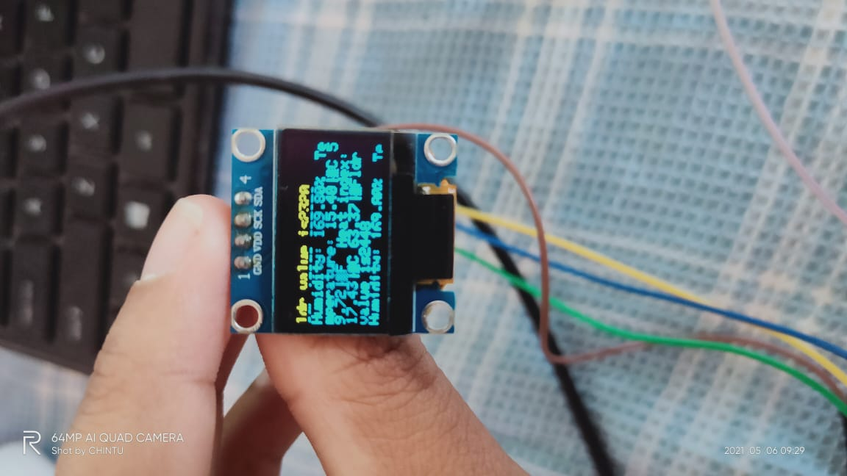
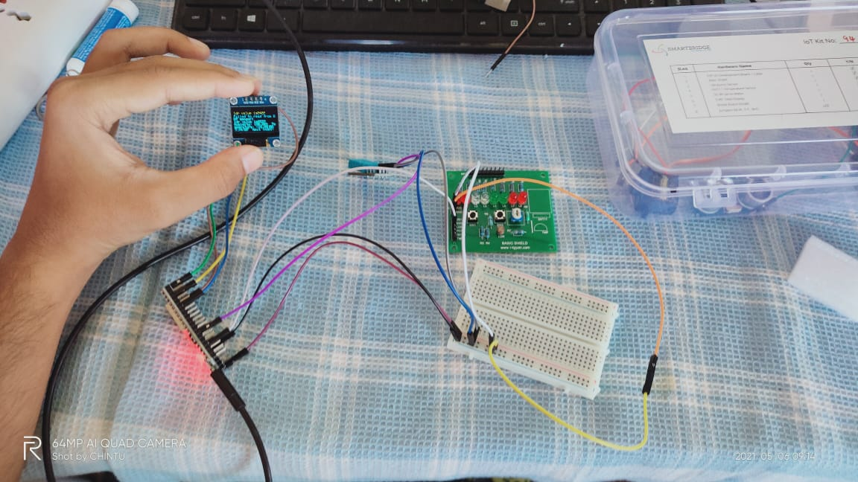
4)CONTROL LIGHTS BASED ON LIGHT INTENSITY
void setup() {
pinMode(4,OUTPUT);
Serial.begin(9600);
}
void loop() {
int ldrval=analogRead(15);
- //int a=digitalRead(4);
Serial.print("the LDR value is:");
Serial.println(ldrval);
delay(1000);
if(ldrval<=2000)
{
digitalWrite(4,LOW);
Serial.println("led is off");
delay(1000);
}
else
{
digitalWrite(4,HIGH);
Serial.println("led is on");
delay(1000);
}}
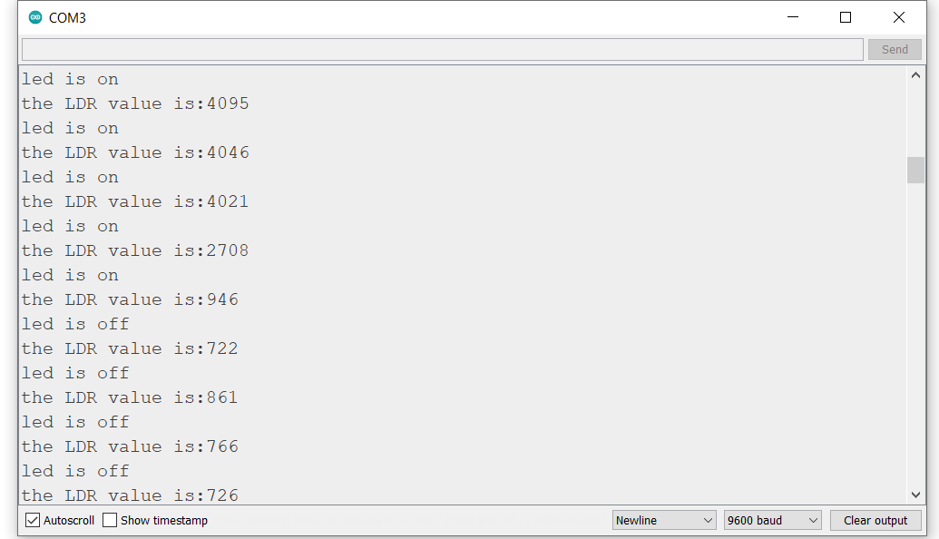

5) CONTROL FANS BASED ON HUMIDITY AND TEMPERATURE.
#include "DHT.h"

#define DHTPIN 4 // Digital pin connected to the DHT sensor
// Feather HUZZAH ESP8266 note: use pins 3, 4, 5, 12, 13 or 14 --
// Pin 15 can work but DHT must be disconnected during program upload.

// Uncomment whatever type you're using!
//#define DHTTYPE DHT11 // DHT 11
#define DHTTYPE DHT11 // DHT 22 (AM2302), AM2321
//#define DHTTYPE DHT21 // DHT 21 (AM2301)

// Connect pin 1 (on the left) of the sensor to +5V
// NOTE: If using a board with 3.3V logic like an Arduino Due connect pin 1
// to 3.3V instead of 5V!
// Connect pin 2 of the sensor to whatever your DHTPIN is
// Connect pin 3 (on the right) of the sensor to GROUND (if your sensor has 3 pins)
// Connect pin 4 (on the right) of the sensor to GROUND and leave the pin 3 EMPTY (if your sensor has 4 pins)
// Connect a 10K resistor from pin 2 (data) to pin 1 (power) of the sensor

// Initialize DHT sensor.
// Note that older versions of this library took an optional third parameter to
// tweak the timings for faster processors. This parameter is no longer needed
// as the current DHT reading algorithm adjusts itself to work on faster procs.
DHT dht(DHTPIN, DHTTYPE);

void setup() {
Serial.begin(9600);
Serial.println(F("DHTxx test!"));
pinMode(2,OUTPUT);
dht.begin();
}

void loop() {
// Wait a few seconds between measurements.
delay(2000);

// Reading temperature or humidity takes about 250 milliseconds!
// Sensor readings may also be up to 2 seconds 'old' (its a very slow sensor)
float h = dht.readHumidity();
// Read temperature as Celsius (the default)
float t = dht.readTemperature();
// Read temperature as Fahrenheit (isFahrenheit = true)
float f = dht.readTemperature(true);

// Check if any reads failed and exit early (to try again).
if (isnan(h) || isnan(t) || isnan(f)) {
Serial.println(F("Failed to read from DHT sensor!"));
return;
}

// Compute heat index in Fahrenheit (the default)
float hif = dht.computeHeatIndex(f, h);
// Compute heat index in Celsius (isFahreheit = false)
float hic = dht.computeHeatIndex(t, h, false);

Serial.print(F("Humidity: "));
Serial.println(h);
Serial.print(F("% Temperature: "));
Serial.println(t);
Serial.print(F("°C "));
Serial.println(f);
Serial.print(F("°F Heat index: "));
Serial.println(hic);
Serial.print(F("°C "));
Serial.print(hif);
Serial.println(F("°F"));
delay(2000);

if((h<=56)&&(t<32.0))
{
digitalWrite(2,LOW);
delay(2000);
Serial.println("fan is off");
}
else
{
digitalWrite(2,HIGH);
delay(2000);
Serial.println("fan is on");

}
}
